Finding An efficient Path For Mars Rover

Flowchart
Start

load Terrain.mat
V=0.01/1000;
cg=1;cycle=50;h=T/1000;C=1/20000;
[ segment,TerrainFile,xs,ys,xe,ye,nwp,wp ] = getProjectInput( 'path.ini' );

[xp_orig,yp_orig,hp_orig,d_orig,eplus_orig,eminus_orig]=computepath(xs,ys,xe,ye,nwp,wp,x,y,h,segment);
hmin_orig=min(hp_orig);
hmax_orig=max(hp_orig);
[J_orig] = compute_cost( C,V,g,x,y,h,xs,xe,ys,ye,segment,nwp,wp );
[xp_opt yp_opt hp_opt J_opt eplus_opt eminus_opt]=optimizewithcost( x,y,h,dhdx,dhdy,g,C,V,cg,cycles,nwp,wp,xs,ys,xe,ye,segment );
hmin_opt=min(hp_opt);
hmax_opt=max(hp_opt);

Output:
Metrics for the original path:
d_orig, J_orig, hmin_orig, hmax_orig, eplus_orig, eminus_orig
The original path:
xp_orig, yp_orig, hp_orig
Metrics for the optimized path:
d_opt, J_opt, hmin_opt, hmax_opt, eplus_opt, eminus_opt
The optimized path
xp_opt, yp_opt, hp_opt

Task 1
end

1.Include and succinctly discuss the tables and figures for parts A-E of Task 1. Make sure all the figures are have axis labels and legends where appropriate.
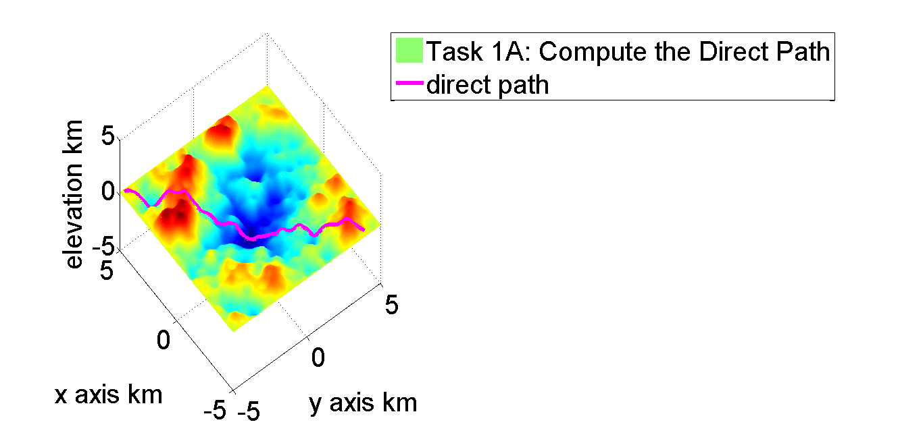

This figure describes the direct path with no way points.

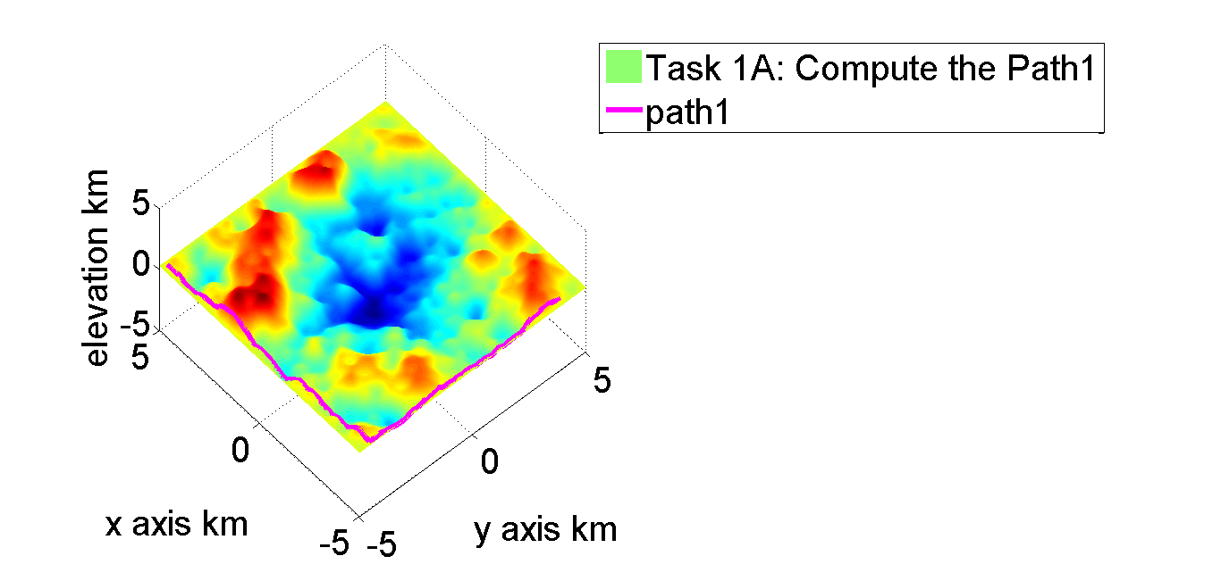

This figure describes the path1 with 1 way point.

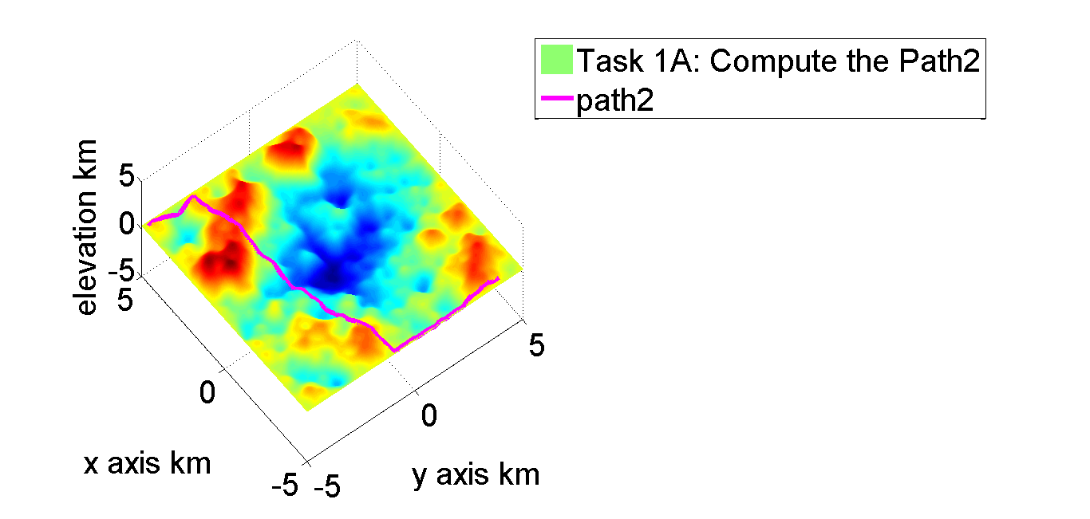

This figure describe the path2 for 2 way points.
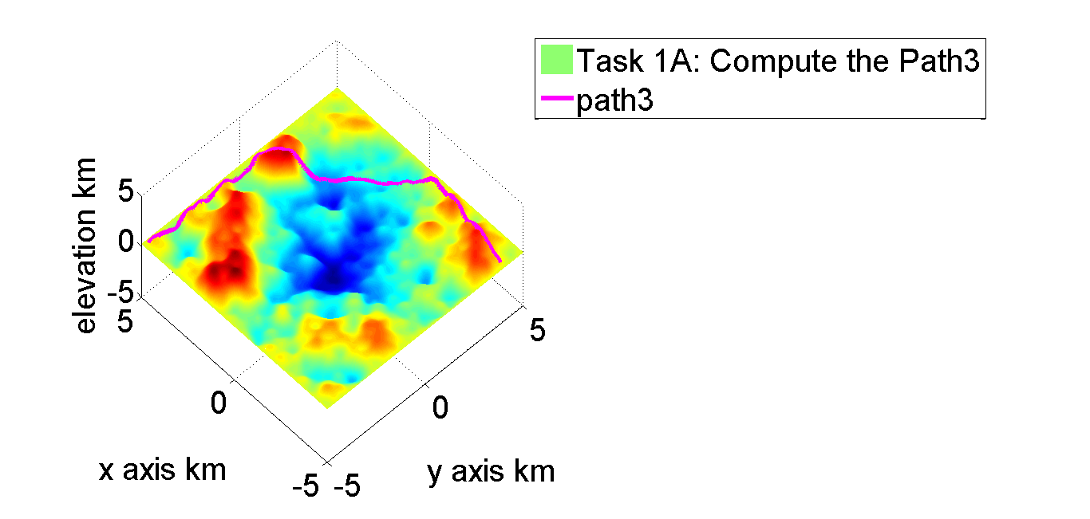
This figure describes the path 3 with 2 way points.

Task 1C: Comparison of 4 Paths
Route | Time(s) | Distance(km) | plusElev.(km) | minusElev.(km)
Direct | 1.93E+06 | 17.84787666 | 5.473723422 | 5.559382255
Paht1 | 1.97E+06 | 19.67570946 | 2.974675037 | 3.06033387
Paht2 | 1.92E+06 | 19.16072202 | 3.852238329 | 3.937897162
Path3 | 2.11E+06 | 21.09318814 | 5.512815453 | 5.598474286

Path3 takes the longest time with longest distance with relatively big elevation difference.
The direct path takes the shortest distance while takes long time and its elevation difference is huge.
The path1 and path2 take almost the same time ,which is less than path 3 and the direct path, and distance but path1 does not have much path going uphill or downhill like path2.

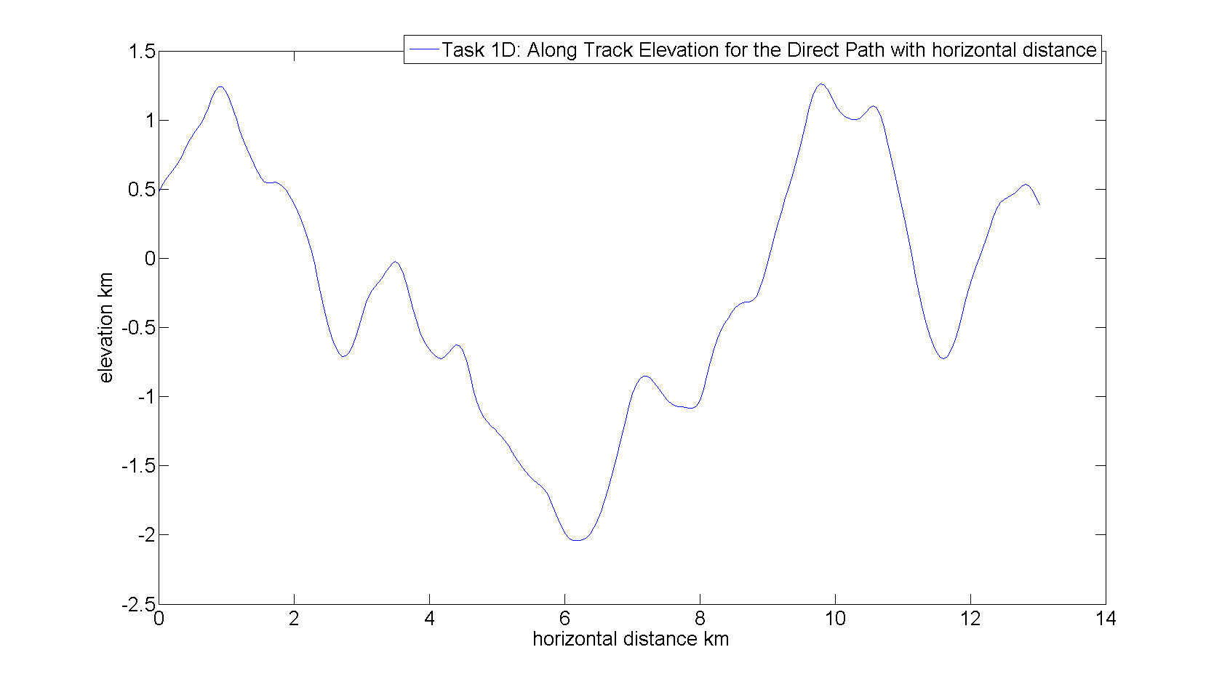
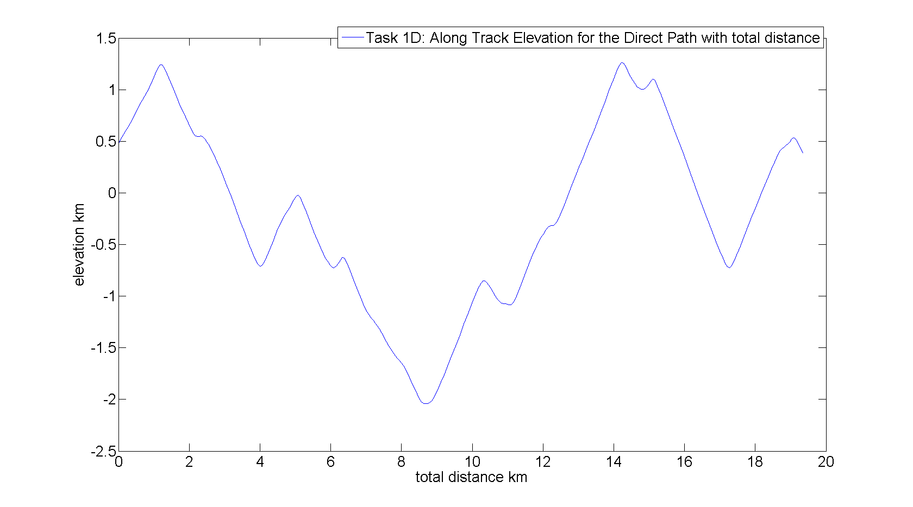
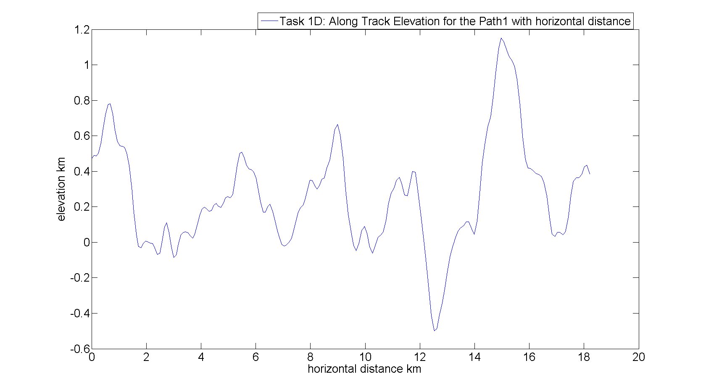

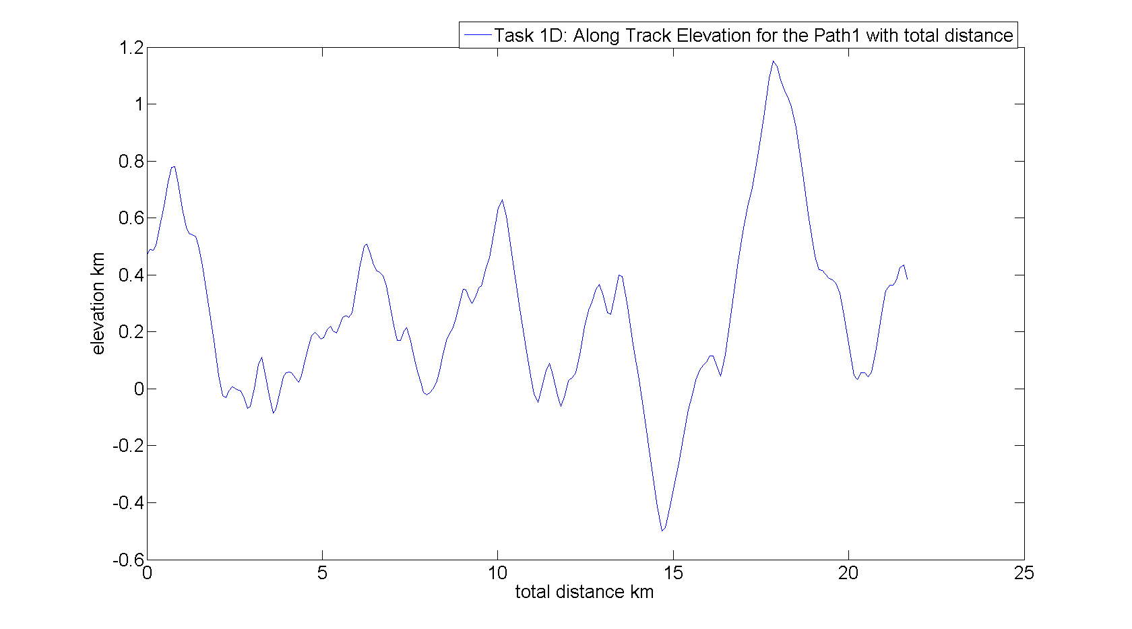
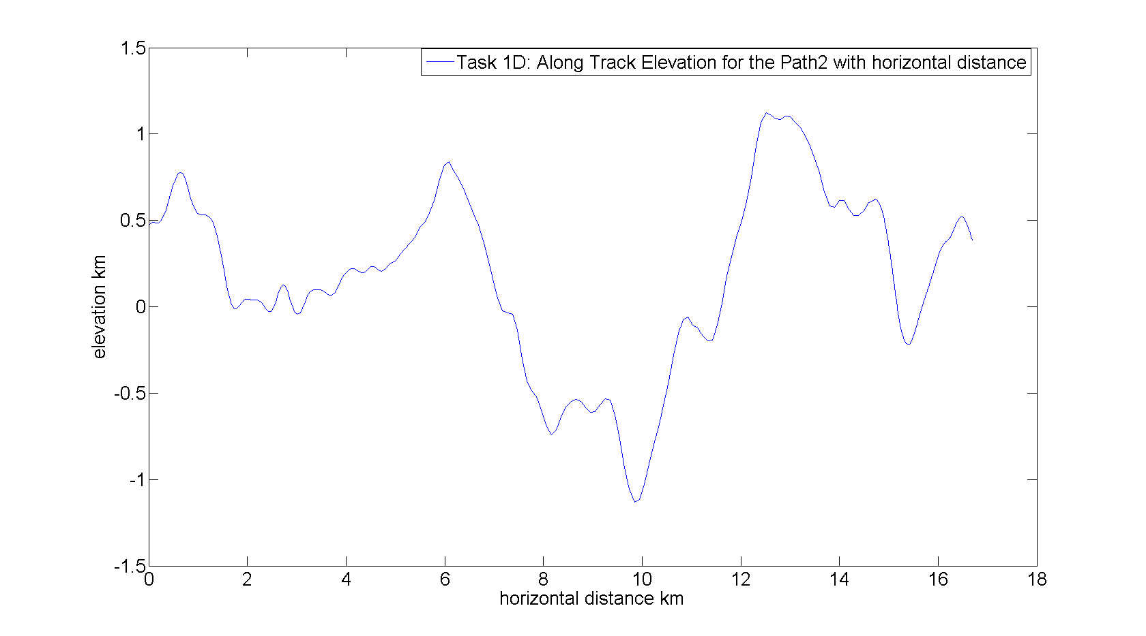
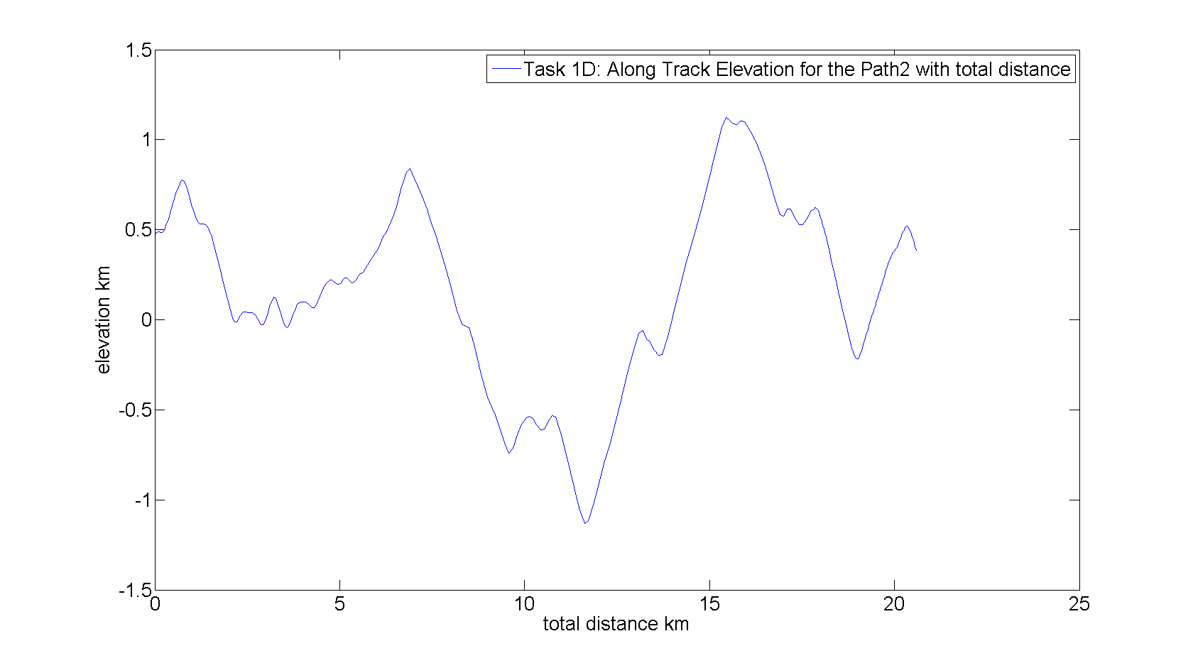
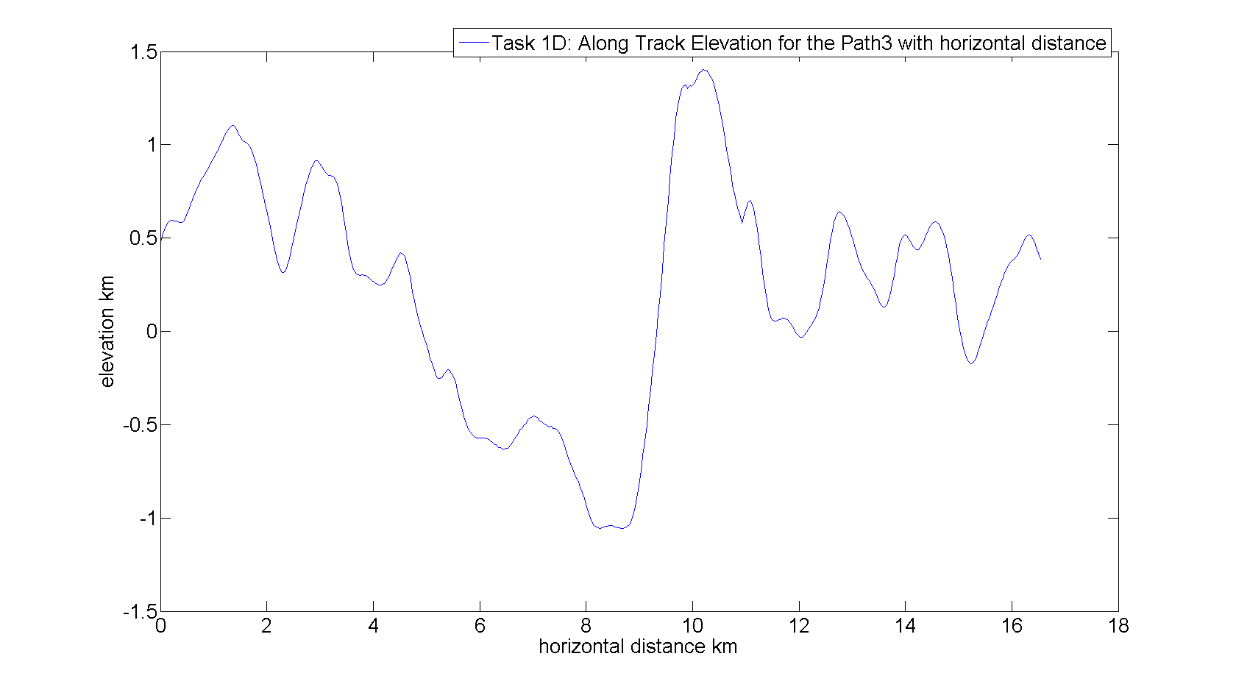
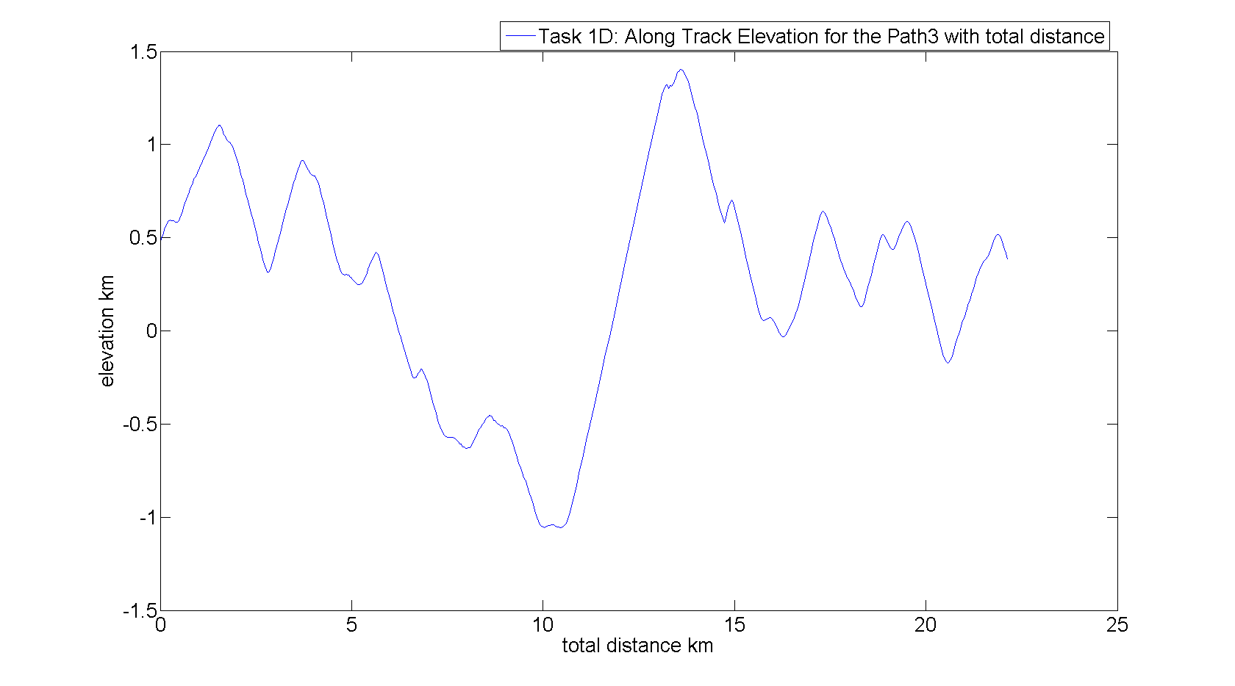
These eight figures show the distance versus elevation. The difference between the graph with toal distance and the graph with horizontal distance is that total distance is usually bigger than horizontal distance and besides the trend for each path between total and horizontal distance is almost the same. From the graph, we can see that path2 has more peaks along the path and the direct path seems to be more flat than others.

2.Re-compute the paths with 200%, 50% and 25% and 10% of the points per segment and discuss the difference. You many find tabulating the results a useful departure point for the discussion.

200%
Route | Time(s) | Distance(km) | plusElev. | minusElev. | max(h) | min(h)
Direct | 1.94E+03 | 19.4265059 | 6.49546956 | 6.581128394 | 1.264760758 | -2.043324102
Paht1 | 2.17E+03 | 21.74776564 | 4.908154605 | 4.993813438 | 1.154931347 | -0.503664897
Paht2 | 2.07E+03 | 19.16072202 | 5.106776962 | 5.192435795 | 1.126133347 | -1.134239221
Path3 | 2.23E+03 | 22.2745280475674 | 6.239111513 | 6.324770346 | 1.401311662 | -1.055690632

50%
Route | Time(s) | Distance(km) | plusElev. | minusElev. | max(h) | min(h)
Direct | 1.93E+03 | 19.28747579 | 6.417741574 | 6.503400407 | 1.259298711 | -2.044172752
Paht1 | 2.14E+03 | 21.39785091 | 4.502445379 | 4.588104213 | 1.147092843 | -0.461127896
Paht2 | 2.04E+03 | 19.16072202 | 4.978099087 | 5.06375792 | 1.118607718 | -1.133179126
Path3 | 2.21E+03 | 22.0800839095652 | 6.147750485 | 6.233409318 | 1.403079489 | -1.055582664

25%
Route | Time(s) | Distance(km) | plusElev. | minusElev. | max(h) | min(h)
Direct | 1.90E+03 | 19.01908133 | 6.2518646 | 6.337523433 | 1.261583656 | -2.043955473
Paht1 | 2.06E+03 | 20.63300516 | 3.976302317 | 4.061961151 | 1.151881256 | -0.503708607
Paht2 | 2.01E+03 | 19.16072202 | 4.749801218 | 4.835460052 | 1.098007766 | -1.106456959
Path3 | 2.19E+03 | 21.9247152290454 | 6.034945228 | 6.120604061 | 1.402035986 | -1.055008711

10%
Route | Time(s) | Distance(km) | plusElev. | minusElev. | max(h) | min(h)
Direct | 1.78E+03 | 17.84787666 | 5.473723422 | 5.559382255 | 1.259298711 | -1.953718182
Paht1 | 1.97E+03 | 19.67570946 | 2.974675037 | 3.06033387 | 1.151881256 | -0.340433333
Paht2 | 1.92E+03 | 19.16072202 | 3.852238329 | 3.937897162 | 1.124103121 | -0.73943993
Path3 | 2.11E+03 | 21.0931881371062 | 5.512815453 | 5.598474286 | 1.391082257 | -1.053528372

From the above table, We can see that with more points, each path takes more time, longer distance,less +elevation and -elevation. However, both max and min h follow the trend that it becomes bigger first and then it become smaller.

3.Add arrows to a surface or contour plot in the direction of -grad(h) with appropriate magnitude along the path. Discuss what significance these arrows have with respect to an ideal path.
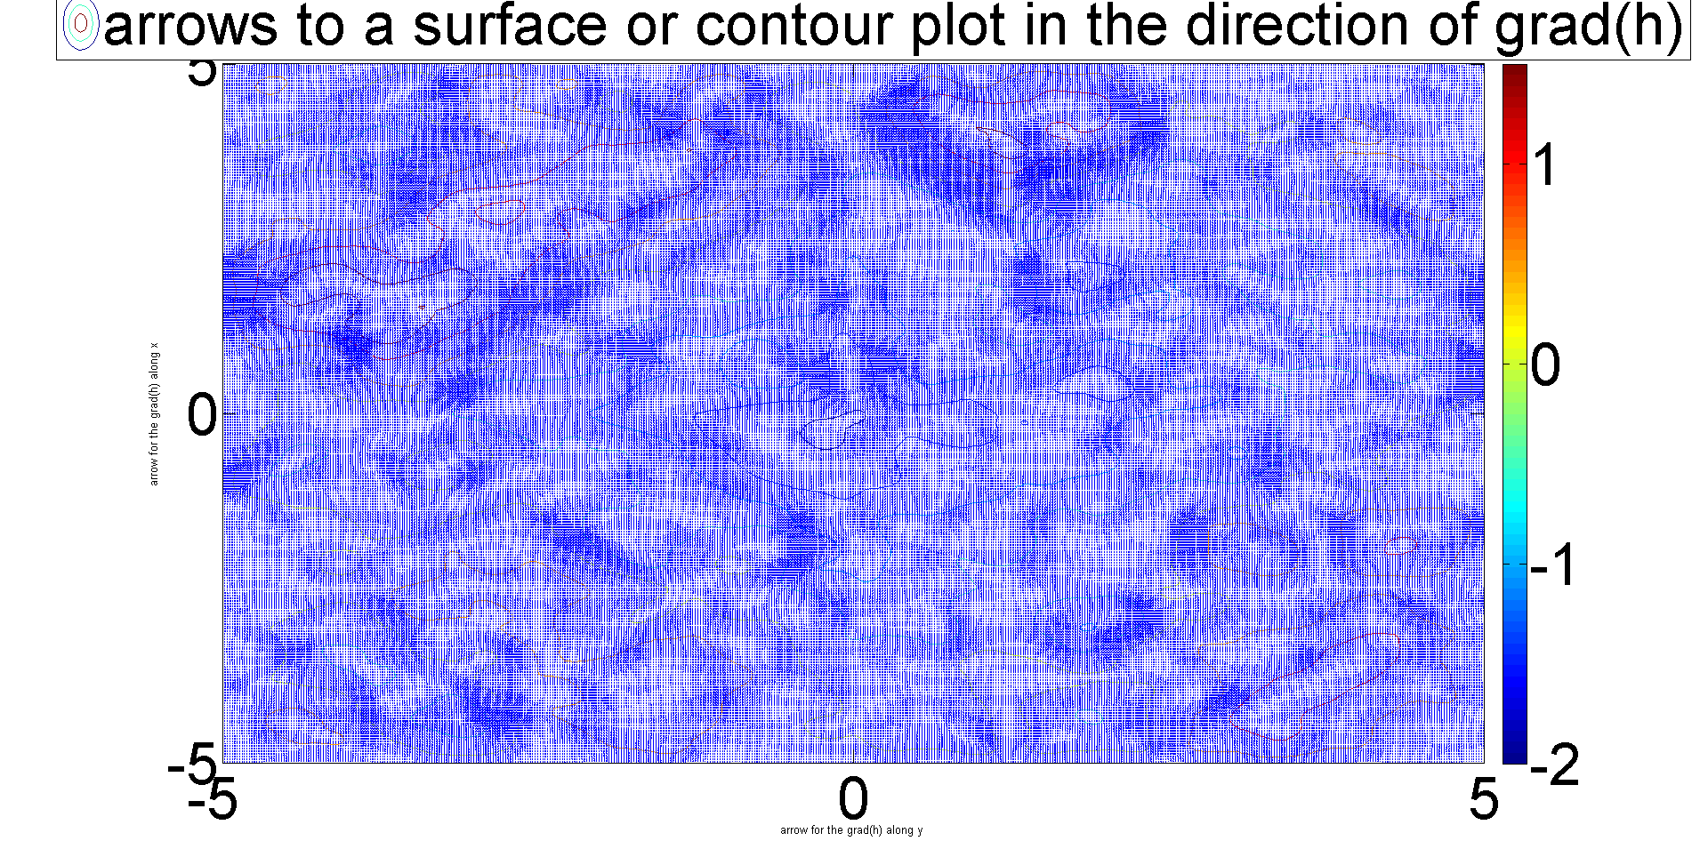

These arrows indicate the direction of the change of elevation along the horizontal distance.
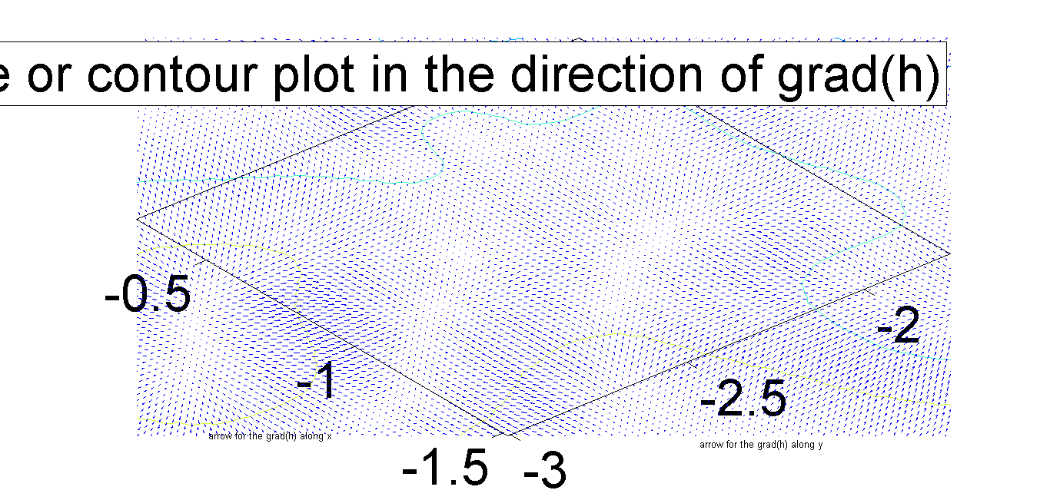
This is the zoomed in version so that you can see the arrows.

Task 2
1. Include and succinctly discuss the tables and figures for parts A-D of task
2. Make sure all the figures are have axis labels and legends where appropriate.
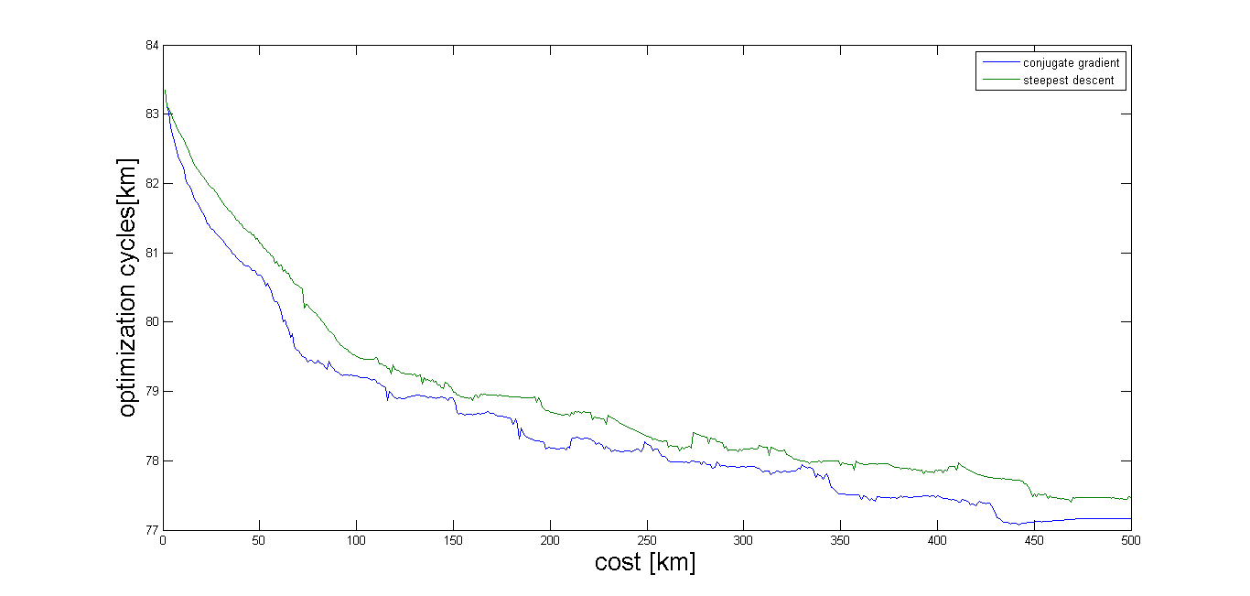
This figure is Cost v. Optimization cycles for the Direct Path.For the direct path,the conjugate gradient and steepest descent does not converge within 500 cycles.
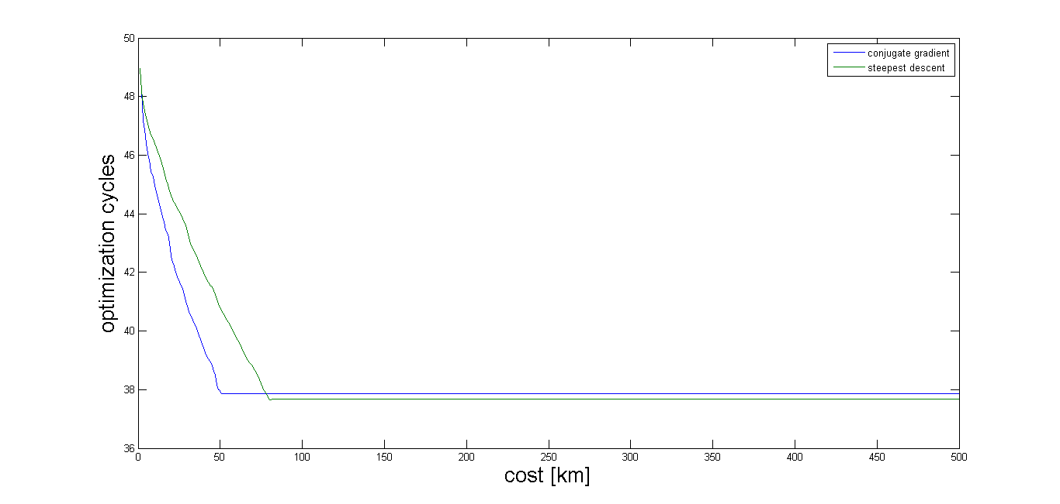
This is Cost v. Optimization cycles for the Path1.For the path1, the conjugate gradient and steepest descent converges at around 80 cycles.

1. Make a table of the cost before and after the optimization and the
number of cycles needed for the optimized to converge. The table
should include all the same quantities as the table in Task 1C for both the
original and optimal paths, as well as the min and max elevations on the
path for both the original and optimized paths.
Route | Time(s) | Distance(km) | plusElev. | minusElev. | max(h) | min(h)
Direct | 1.93E+06 | 17.84787666 | 5.473723422 | 5.559382255 | 1.263315724 | -2.042469512
Paht1 | 1.97E+06 | 19.67570946 | 2.974675037 | 3.06033387 | 1.151881256 | -0.499168831
Paht2 | 1.92E+06 | 19.16072202 | 3.852238329 | 3.937897162 | 1.124103121 | -1.130899753
Path3 | 2.11E+06 | 21.09318814 | 5.512815453 | 5.598474286 | 1.401906785 | -1.055579823
Direct_opt | 1.88E+03 | 18.83762911 | 5.411817973 | 5.497476806 | 1.226172204 | -2.011619304
Paht1_opt | 2.02E+03 | 20.18039032 | 2.592727074 | 2.678385908 | 0.471390065 | -0.239225834
Paht2_opt | 1.98E+03 | 19.76292818 | 3.735353881 | 3.821012715 | 1.110282567 | -0.9705264
Path3_opt | 2.08E+03 | 20.82995785 | 4.25763123 | 4.343290063 | 1.140757534 | -0.897474664

This table shows that for direct path and path3, optimized paths take less time ,distance,+elevation,-elevation than non-optimized path. All the optimized path have smaller max and min than the non-optimized one. Although the optimized path1 and path2 take longer time, distance, all the optimized path actually take smaller +elevation and -elevation, which means they consume less energy and expend less money.

Route | cost
Direct | 3.04E+02
Paht1 | 1.48E+02
Paht2 | 2.04E+02
Path3 | 3.46E+02
Direct_opt | 77.16008049
Paht1_opt | 37.86562883
Paht2_opt | 51.73211448
Path3_opt | 59.91508154

This table shows the cost of paths before and after optimized. From the table, we can see that optimized path saves money.

Route | converge cycle
Direct_st | 630
Paht1_st | 80
Paht2_st | 84
Path3_st | 1230
Direct_cg | 465
Paht1_cg | 50
Paht2_cg | 50
Path3_cg | 850

This table show the number of convergence cycle and for both steepest descent and conjugate gradient path. The steepest descent optimization takes more cycles to converge to an optimized path compared to the conjugate gradient, as evidenced by comparing the data, and the blue line and the green line. However, both converge to about the same value.

2.Plot the elevation versus along-track distance for each path both original
and optimized. (x-y) plots. Each Path should be in a separate plot
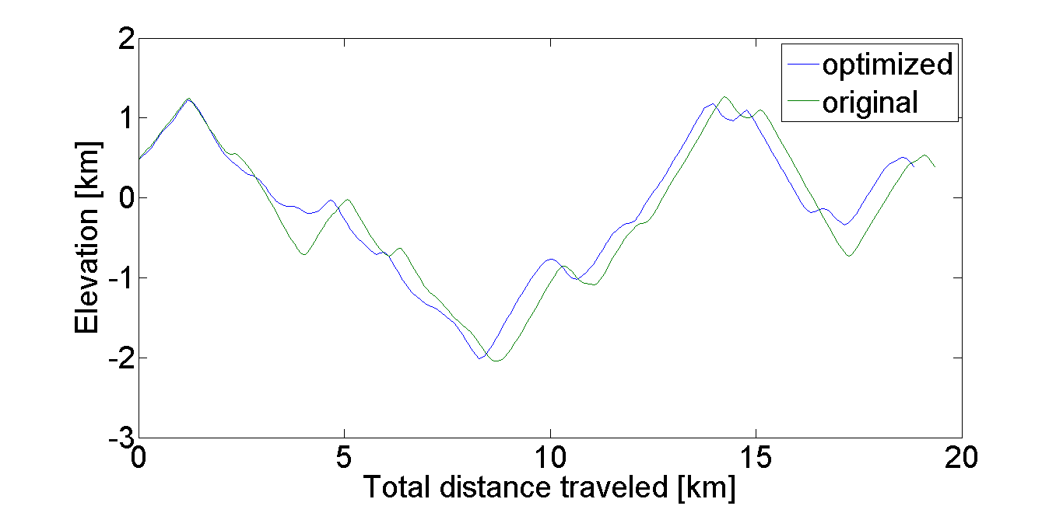
elevation versus along-track distance for direct path
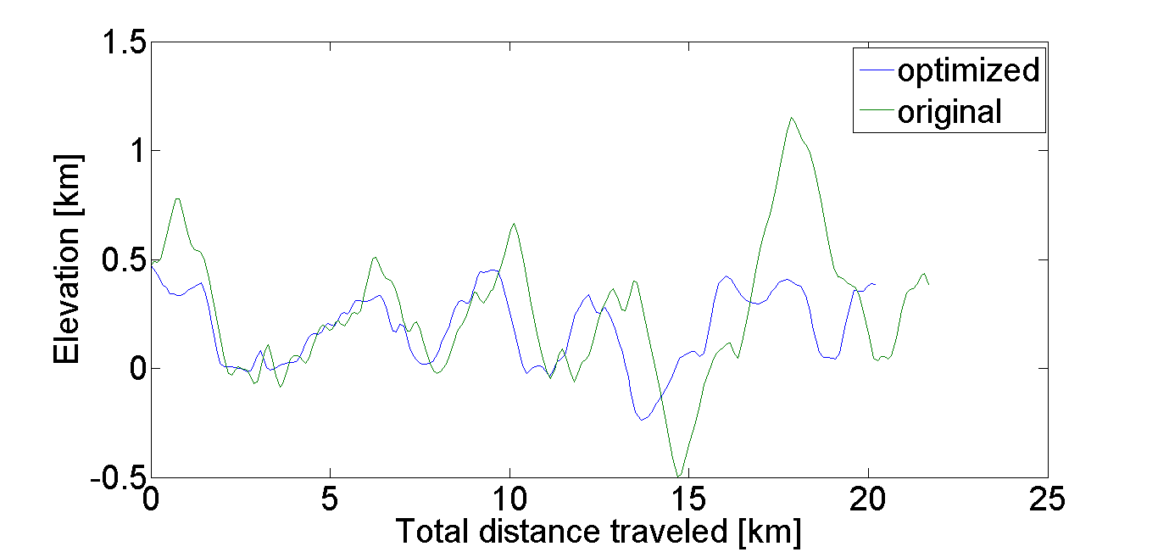
elevation versus along-track distance for path1
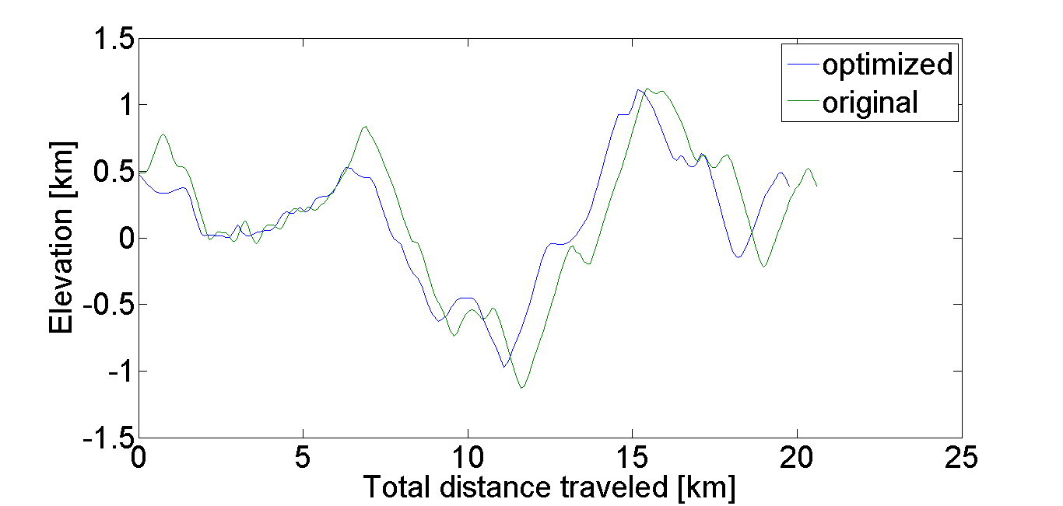
elevation versus along-track distance for path2

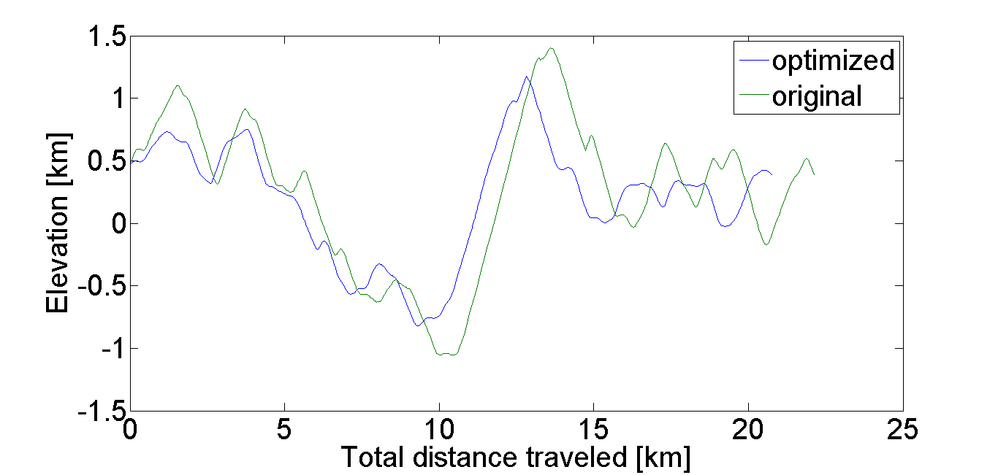
elevation versus along-track distance for path3

The above three figure show that original paths have longer distance than the optimized paths.
Moreover, the original and the optimized path diverge more seriously if the distance is bigger. The optimized path seems to be less fluctuated on the elevation than the original one.

3. Plot both the original and optimal paths on a three-dimensional surface
plot.
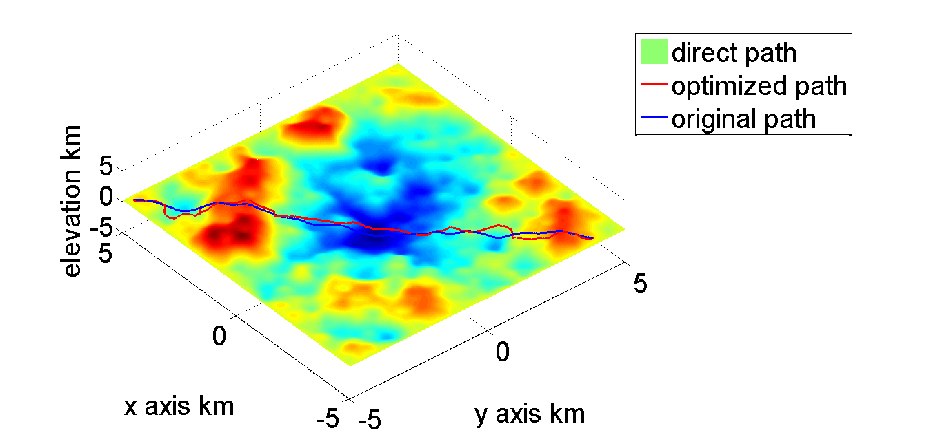
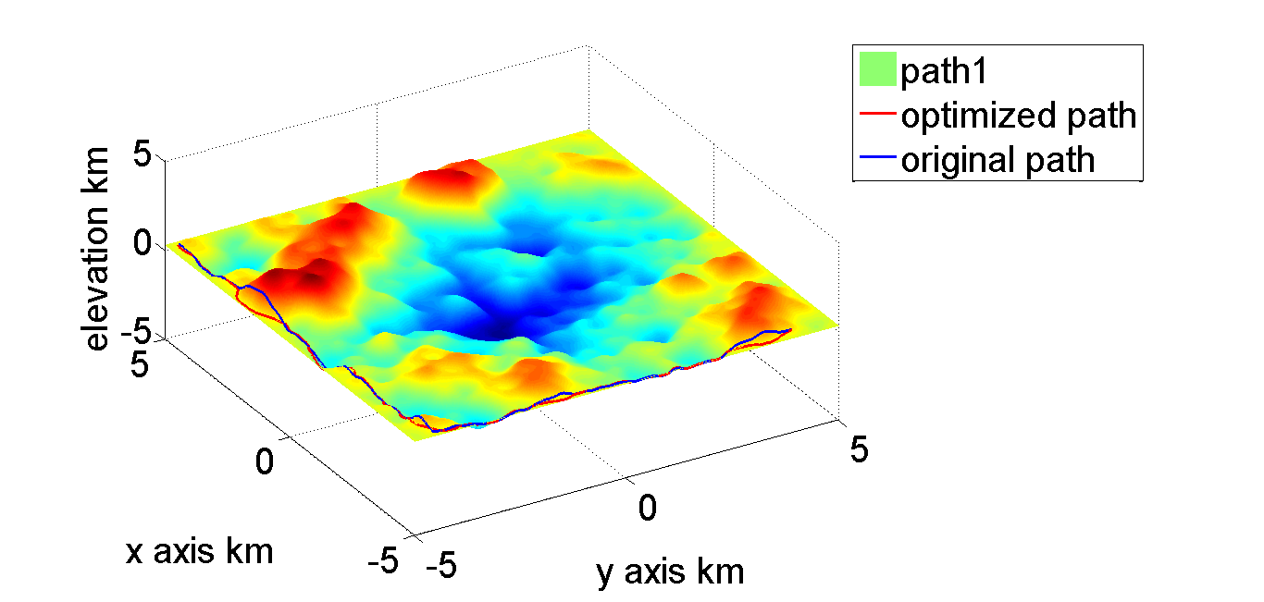
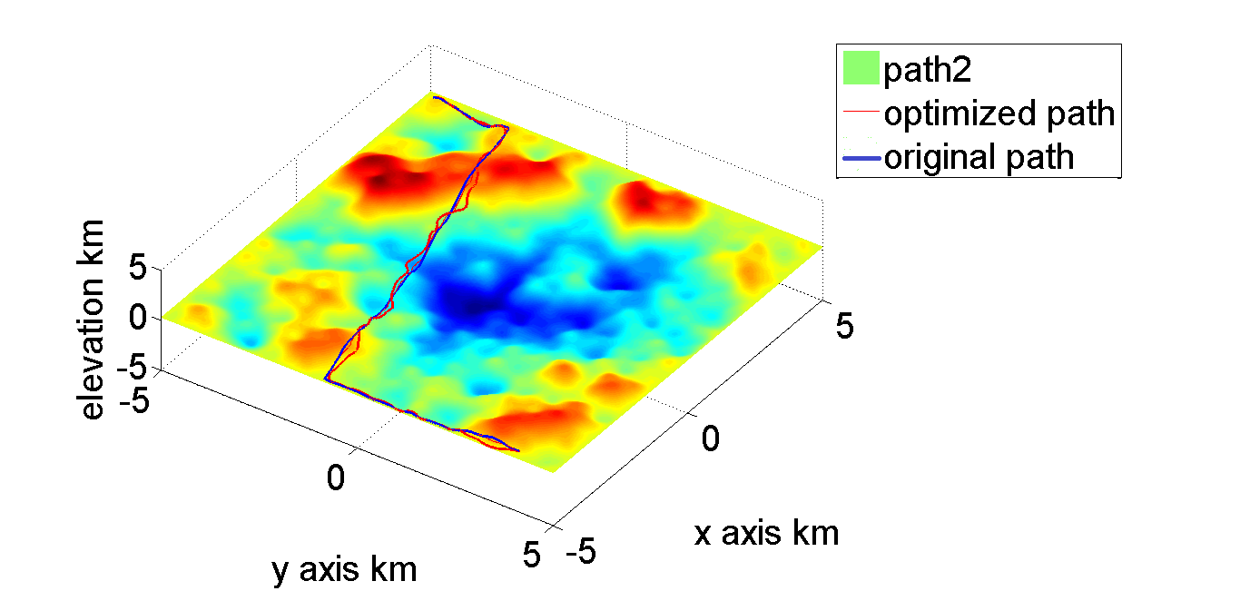
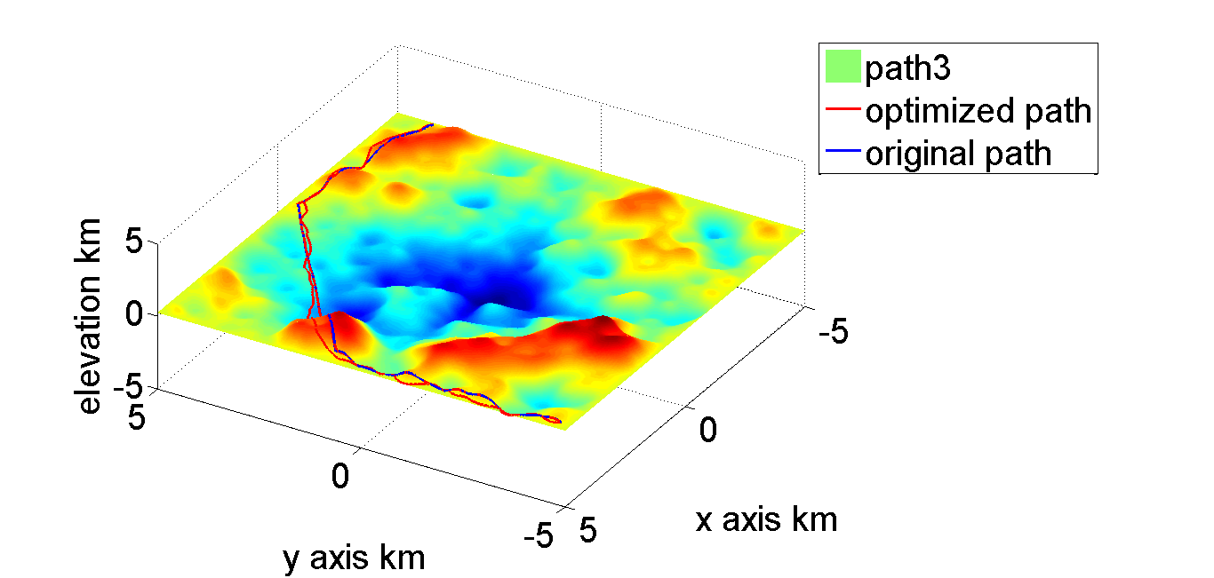

2. Re-compute the optimized paths with 50% and 25% and 10% of the points
per segment and discuss the differences observed. In particular, the cost
savings per iteration, and the changes in the cost J should be compared.
Again, you many find tabulating the results a useful departure point for
the discussion.
cost[km] | 50% | change 50%-25% | 25% | change 25%-10% | 10%
Direct_st | 76.2952946 | -0.5355 | 76.83080414 | 1.8951 | 74.93568656
Paht1_st | 38.31309307 | 0.6046 | 37.70846583 | -0.0559 | 37.76437172
Paht2_st | 52.33373605 | 0.2721 | 52.06166981 | -0.4339 | 52.49559658
Path3_st | 57.41725324 | 1.3497 | 56.06752484 | -0.5473 | 56.61485639

From the table, we can see that for path1,2,3, the cost first decrease from 50% points to 25% points and then increases from 25%points to 10%points. However, for the direct path,the cost first increases from 50% points to 25% points and then decreases from 25%points to 10%points.

3. Modify descent.m so that the parameter dmax is variable. Then develop
an algorithm that such that the path continually refines from 50 points
initially to around 250 points over the span of 100 or so iterations.
Compare the cost on the same path with 250 initial points and a constant
dmax.
cost with modified dmax | cost without
7.07E+09 | 7.00E+09
From the table, we see that the path with modified dmax costs more than the one without because the modified one refines more points.
I use :xp=linspace(xs,xe,50);yp=linspace(ys,ye,50);refine=0.991;
dmax_ini=0.2;cycles=100;

Task 3- Option 1
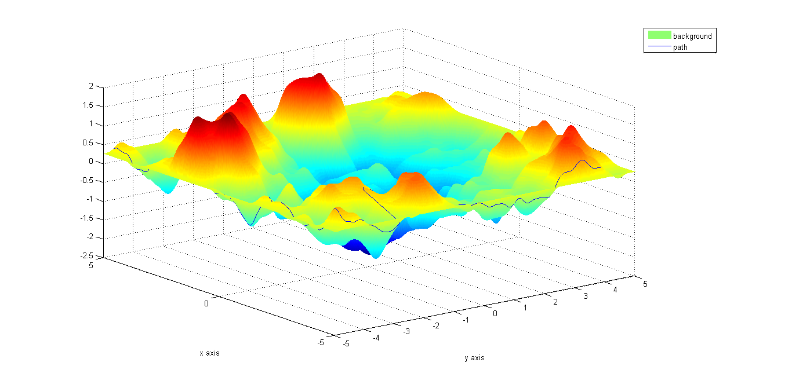

Appendix:
Description for .m file
getProjectInput.m
%This function should be called getProjectInput and take a single
%input, the project file name, project.ini. It should have multiple outputs which are: TerrainFile, StartPoint,
%EndPoint, NumWayPoints, and WayPoints (if NumWayPoints is greater than zero). StartPoint and
%EndPoint should be a 1x2 or 2x1 vector. WayPoints should be a NumWayPoints x 2 or 2 x
%NumWayPoints matrix.

computepath.m
This function generate path without optimization.

compute_cost.m
This function computes cost for the path generated by computepath.m

optimizewithcost.m
This function give you all the output from descent.m and the cost for every iteration but it works for all the path.

descentwithcost.m
This function give you all the output from descent.m and the cost for every iteration but it only works for direct path.

descent.m
% Computes the optimal path (xp,yp) with height hp for a cost function
% of the form J = sum(distance*(1 + (2*g*C*h/V^2)^2) on a terrain.
% Inputs: xp and yp are the path. The gravitational constant (g), the constant
% (C), and velocity are (V) are needed to evaluate the gradient of the cost function.
% cg=0 is steepest descent and cg =1 is conjugate gradient. cycles is the number
% of optimization cycles to perform.
% Outputs: The optimal path (xp,yp) with height (hp) after cycles number of either conjugate
% gradient or steepest descent optimziation.

%
%Parameters
%
%astep: vary a from 0 to amax using this interval size
%amax: maximum displacement of any point during each optimization call
%dmax: The maximum horizontal distance between points. If d > dmax a point is added
% in between. Used in check_path_points.
%disp_cost: if set to true the cost after each optimization cycle is output to the
% screen

descentop.m
The modified descent to make dmax a variable.

boundary.m
This function achieve the goal that the rover is no longer allowed within 0.15 kilometers from any boundary.

block.m
This function make path to avoid circular region with xc,yc as the center of the circle and r as the radius.

calc_gradients.m
%calc_gradients: Calculates the x and y derivatives
% of a two-dimensional field f.
%Inputs: x,y are the one-dimensional grids, and f is the two-dimensional field.
%Outputs: dfdx and dfdy are the two-dimensional fields of the derivatives.
%
%Comments: This function uses the central difference approximation and Neuman BCs.

%preallocate

compute_cost.m
This function computes the cost for paths.

compute_costop.m
This function computes the cost for optimized paths.

computepath.m
This function compute path with the input from path files.

direct_path.m
This function calculates the direct path.

optimizewithcost.m
This function gives you optimized path and cost for every iteration.

